Implement Client Script and UI Policy for Incident
Naan Mudhalvan Project Final Report
Team ID SWTID-2026-5003 | ServiceNow Incident Management
Team member | Contribution
Kaleeswari G | Team Leader; Milestones 4 and 5; Milestone 6 Activity 1
Devibala. A. S | Milestones 1 to 3
Karthika. M | Milestone 6 Activities 2 to 4
Amirtha Varshini S | Milestone 6 Activity 5 and conclusion

1. INTRODUCTION

1.1 Project Overview
This project configures ServiceNow Incident forms so that client-side UI Policies and Client Scripts guide data entry and enforce selected business rules. The implementation covers a High Impact Control UI Policy, a related Urgency action, onChange urgency population, onSubmit validation for Assigned To, and onCellEdit blocking for State changes made from a list.

1.2 Purpose
The report records the project rationale, requirements, design, implementation plan, available configuration evidence, testing approach, limitations, and future work. The attached screenshots document the configured records and selected Incident form/list states; they do not constitute a signed UAT result or performance benchmark.

2. IDEATION PHASE

2.1 Problem Statement
Incident records depend on accurate impact, urgency, assignment, and state information for triage and resolution. Manual reminders can leave fields incomplete or permit inconsistent updates. This project applies form-level rules to improve consistency and stop selected invalid or disallowed actions before submission.

2.2 Empathy Map Canvas
Perspective | Project-derived observation
Says | “I need to complete an Incident quickly and know which fields are required.”
Thinks | High-impact Incidents need stronger assignment and urgency controls.
Does | Creates and updates Incidents through a form or edits State in a list.
Feels | May be uncertain when a rule changes field behavior or blocks saving.
Needs | Clear prompts, predictable field behavior, and a safe way to correct data.

These points are a project-team interpretation of the workflow, not interview findings.

2.3 Brainstorming
The selected approach uses native ServiceNow client features: a UI Policy with reverse behavior for the non-matching condition, a field action for Urgency, an onChange script for automatic urgency, an onSubmit guard for Assigned To, and an onCellEdit callback to reject direct list edits to State. This keeps the demonstrated controls close to the Incident user interface.

3. REQUIREMENT ANALYSIS

3.1 Customer Journey map
Step | User action | System response
Open | Open or create an Incident | Display the Incident form.
Set impact | Choose High impact | Apply policy behavior; onChange script sets Urgency to High.
Assign | Choose an assignee | Allow submission when the onSubmit rule is satisfied.
Save | Submit the form | Block save when Impact is High and Assigned To is empty.
Edit state | Change State in list or form | Block list cell edit; allow ordinary form update subject to other rules.

3.2 Solution Requirement
ID | Requirement
FR-01 | Apply the High Impact Control UI Policy to Incident when Impact is High.
FR-02 | Make Assignment group mandatory through a UI Policy Action; reverse policy changes when condition becomes false.
FR-03 | Make Urgency read-only while the high-impact policy condition is true.
FR-04 | Set Urgency to High when Impact changes to High.
FR-05 | Prevent form submission when Impact is High and Assigned To is empty; show field feedback.
FR-06 | Reject direct list editing of Incident State with a message.
NFR-01 | Keep the behavior understandable and limited to the Incident client interface.
NFR-02 | Treat client-side checks as usability controls; add server-side validation for enforcement across integrations.

Configuration note: the source project PDF specifies Assignment group as the mandatory UI Policy Action, while its Task 6 narrative describes Assigned To as mandatory. The onSubmit script explicitly checks Assigned To. These are distinct controls and should be confirmed in the live instance.

3.3 Data Flow Diagram
Incident user input → Impact condition evaluation → UI Policy and onChange Client Script → field behavior / Urgency value → onSubmit validation → allow or prevent form submission. For list edits, State cell change → onCellEdit Client Script → callback(false) and user alert.

3.4 Technology Stack
Layer | Technology / role
Platform | ServiceNow platform and Incident table
Form rules | UI Policy and UI Policy Action
Client behavior | ServiceNow Client Scripts: onChange, onSubmit, onCellEdit
Language / API | JavaScript and g_form client API
Evidence | Milestone screenshots supplied in the project ZIP

4. PROJECT DESIGN

4.1 Problem Solution Fit
The requirements concern field behavior and validation during Incident use. Native ServiceNow UI Policies and Client Scripts directly address that interaction and are represented in the supplied screenshots. The solution is suitable as a client-side demonstration; server-side controls are needed if the same rules must cover imports, APIs, or other non-form writes.

4.2 Proposed Solution
Configure the Incident UI Policy “High Impact Control” with Impact is 1 - High and Reverse if false enabled. Configure the policy action for Assignment group mandatory and the Urgency action as read-only. Add the documented client scripts for urgency population, Assigned To save validation, and State list-edit rejection.

4.3 Solution Architecture
Component | Trigger | Effect
High Impact Control UI Policy | Impact = High | Enforces conditional field actions and reverses them when false.
Urgency UI Policy Action | Policy condition true | Sets Urgency read-only.
onChange Client Script | Impact changes | Sets urgency value to 1 for high impact and displays an info message.
onSubmit Client Script | User submits form | Returns false if Impact = 1 and Assigned To is empty.
onCellEdit Client Script | State edited from list | Shows alert and calls callback(false).

5. PROJECT PLANNING & SCHEDULING

5.1 Project Planning
Milestone | Work represented in project evidence
1 | Incident navigation and High Impact Control UI Policy setup
2 | Urgency UI Policy Action
3 | Client Script configuration list and onChange script
4 | onSubmit validation script
5 | onCellEdit State restriction script
6 | Incident form and list checks across the configured behaviors

Team allocation: Kaleeswari G — Team Leader, Milestones 4 and 5 and Milestone 6 Activity 1; Devibala. A. S — first three milestones; Karthika. M — Milestone 6 Activities 2, 3, and 4; Amirtha Varshini S — Milestone 6 Activity 5 and conclusion.

6. FUNCTIONAL AND PERFORMANCE TESTING

6.1 Performance Testing
The available project materials describe functional checks but provide no timing, load, concurrency, or resource measurements. Performance is therefore not claimed as measured. Client-side scripts are small form handlers, but platform performance should be measured in the target instance under representative data and user load before production use.
Check | Expected behavior | Evidence status
High impact field behavior | Configured policy actions appear on the Incident form. | Configuration and form screenshots supplied.
High impact save without assignee | Submission is prevented and field feedback is shown. | A form screenshot shows validation feedback; formal test log not supplied.
State list edit | Alert appears and edit is rejected. | List and alert screenshots supplied.
Form-based State update | A form update can be made through the normal form path. | Screenshot supplied; formal result/sign-off not supplied.
Policy reverse condition | Policy effects revert when Impact is no longer High. | Defined in project instructions; execution result not formally recorded.

7. RESULTS

7.1 Output Screenshots
The following supplied screenshots are grouped by implementation milestone. Captions identify what each image is intended to show; they are not independent test certifications.
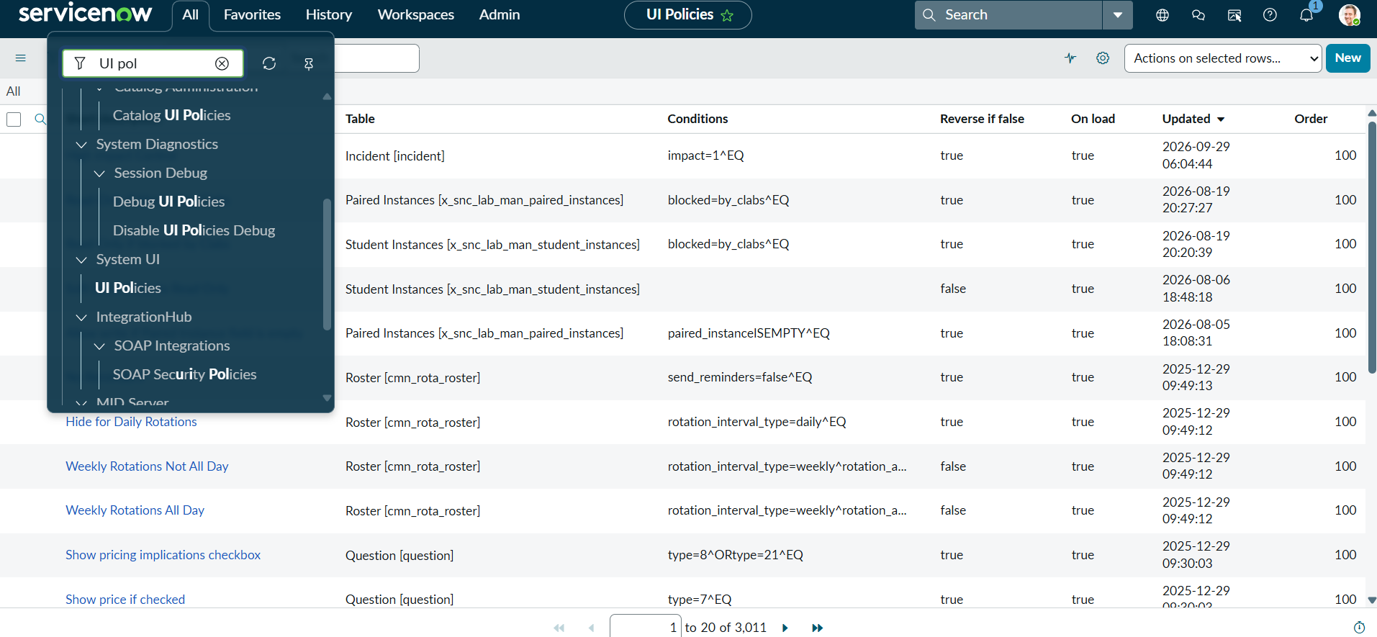
Milestone 1: Incident workspace and navigation.
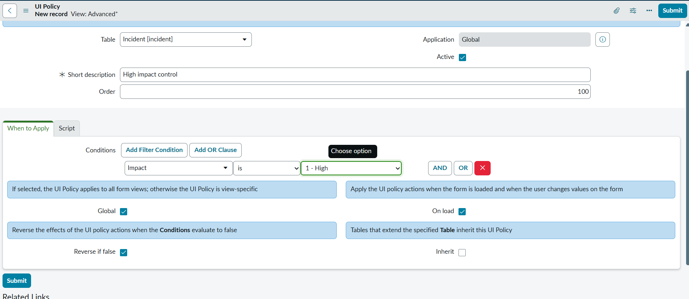
Milestone 1: Incident form with high-impact behavior.
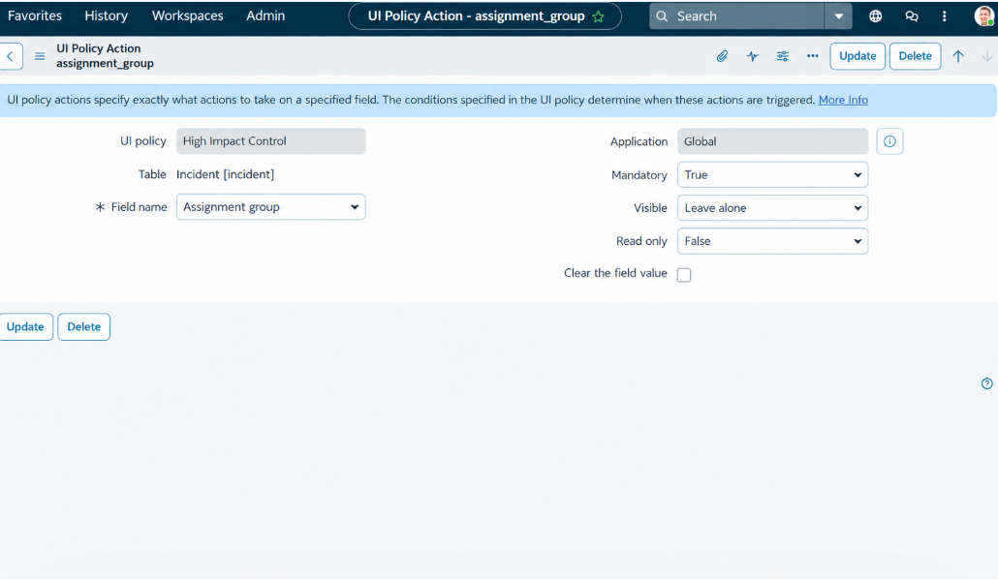
Milestone 1: High Impact Control UI Policy and Assignment group action.
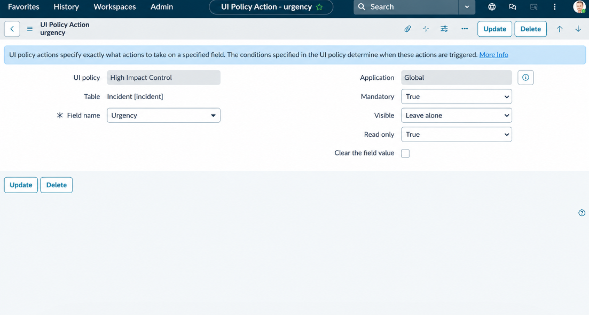
Milestone 2: Urgency UI Policy Action.
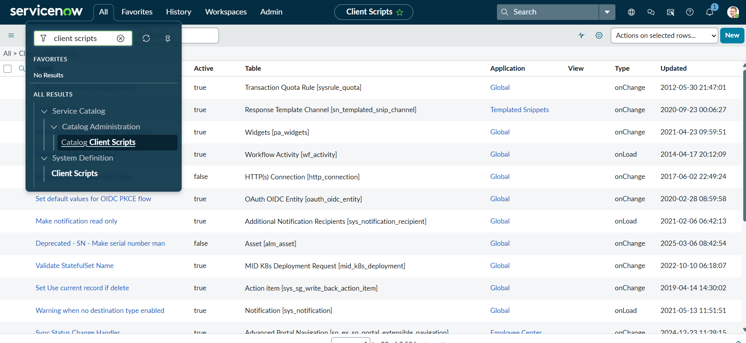
Milestone 3: Client Scripts list.
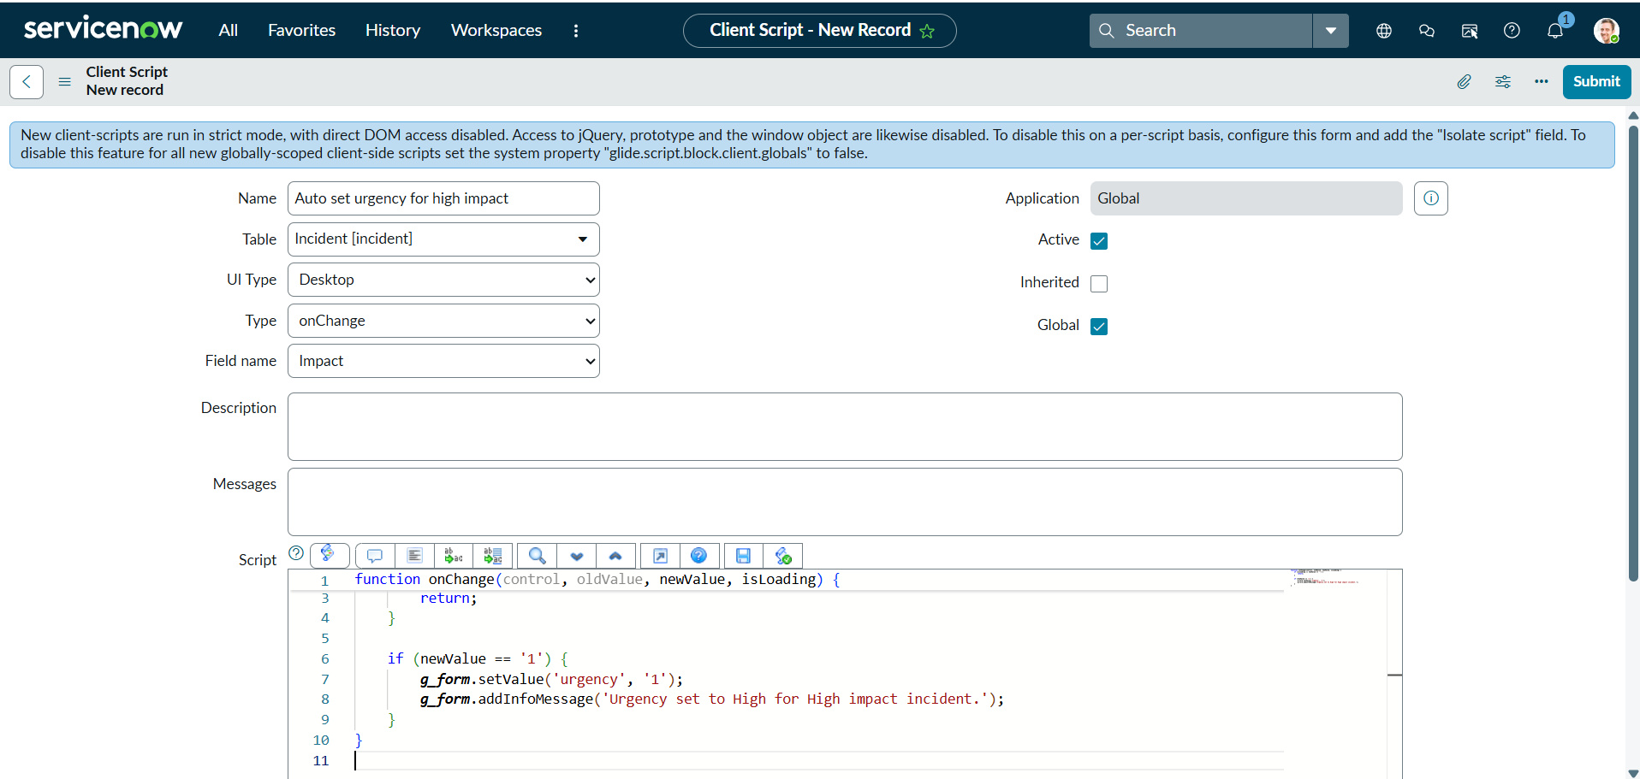
Milestone 3: onChange script configuration.
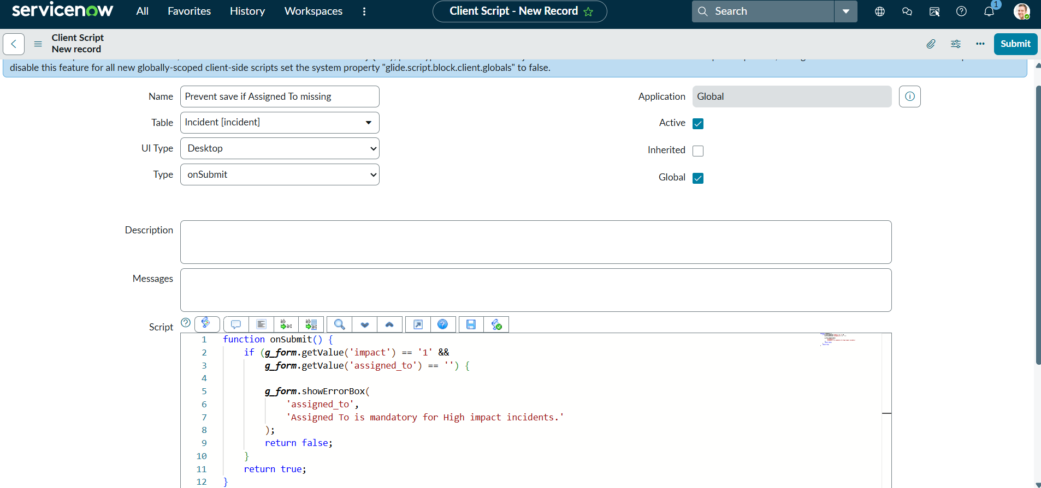
Milestone 4: onSubmit validation configuration.
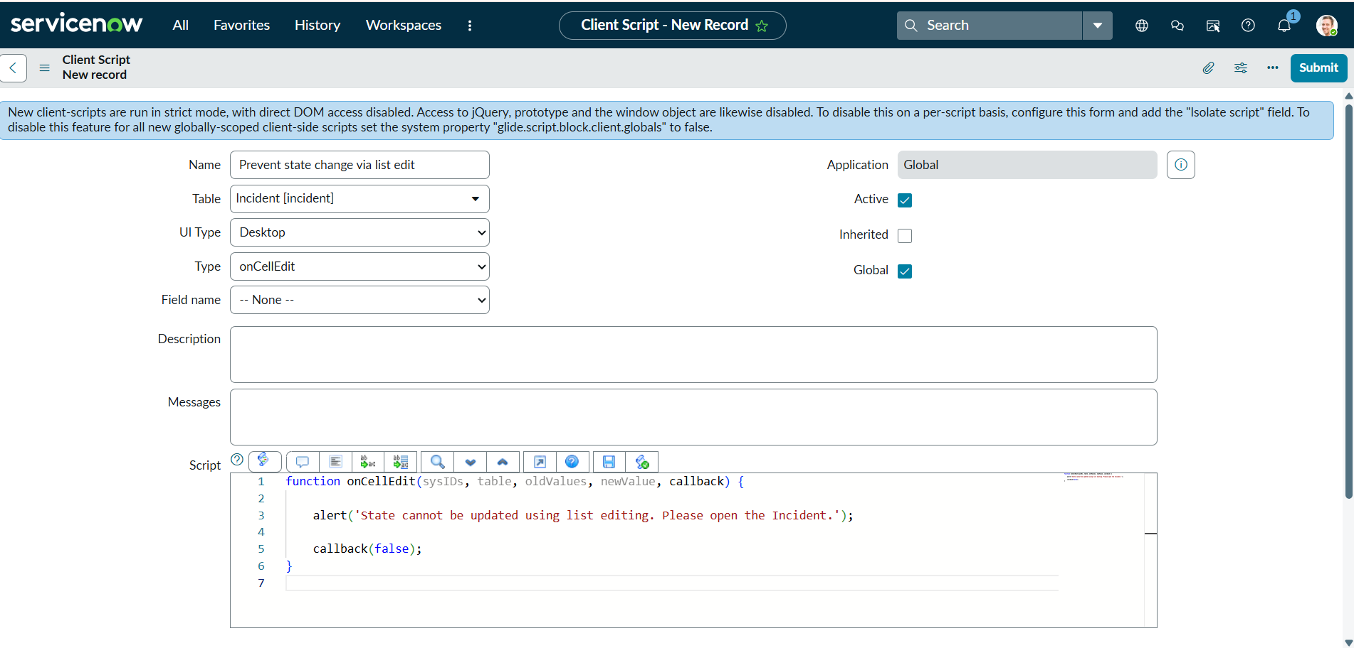
Milestone 5: onCellEdit State restriction configuration.
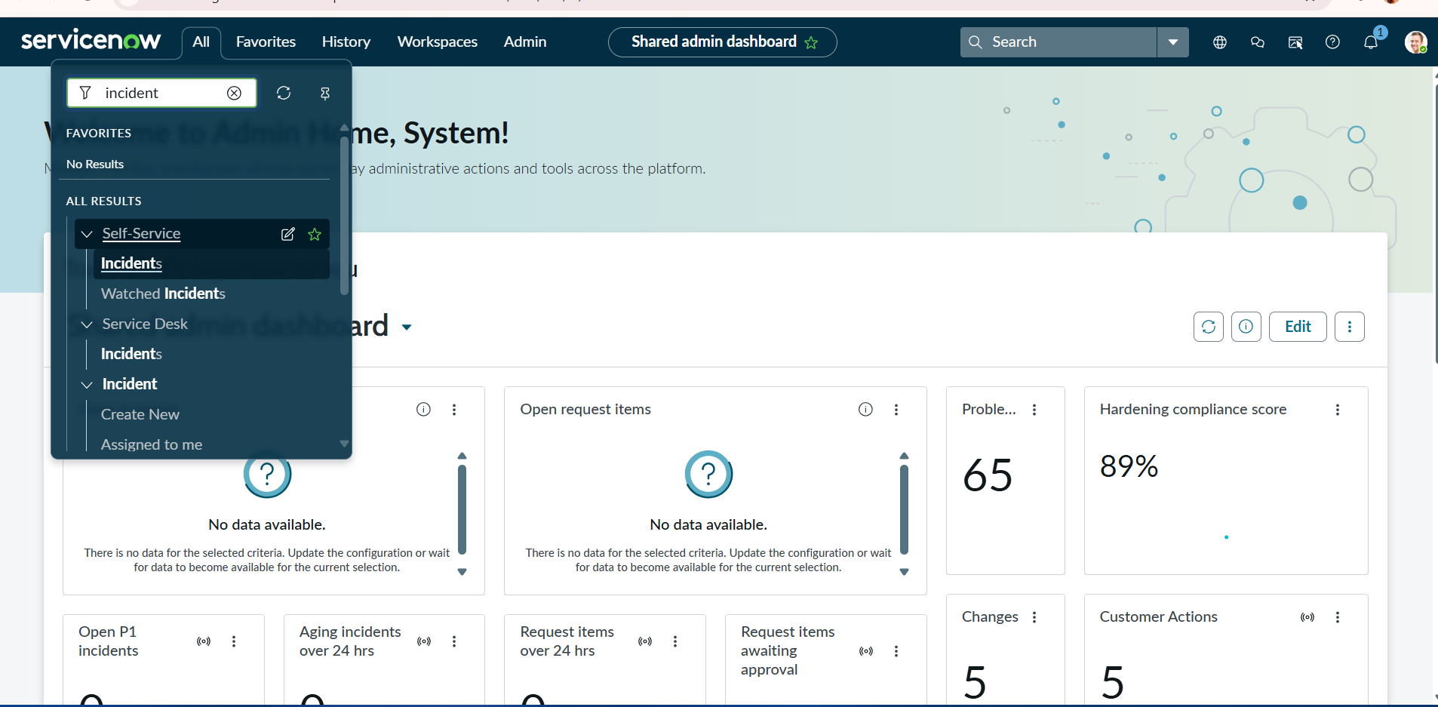
Milestone 6: ServiceNow workspace context.
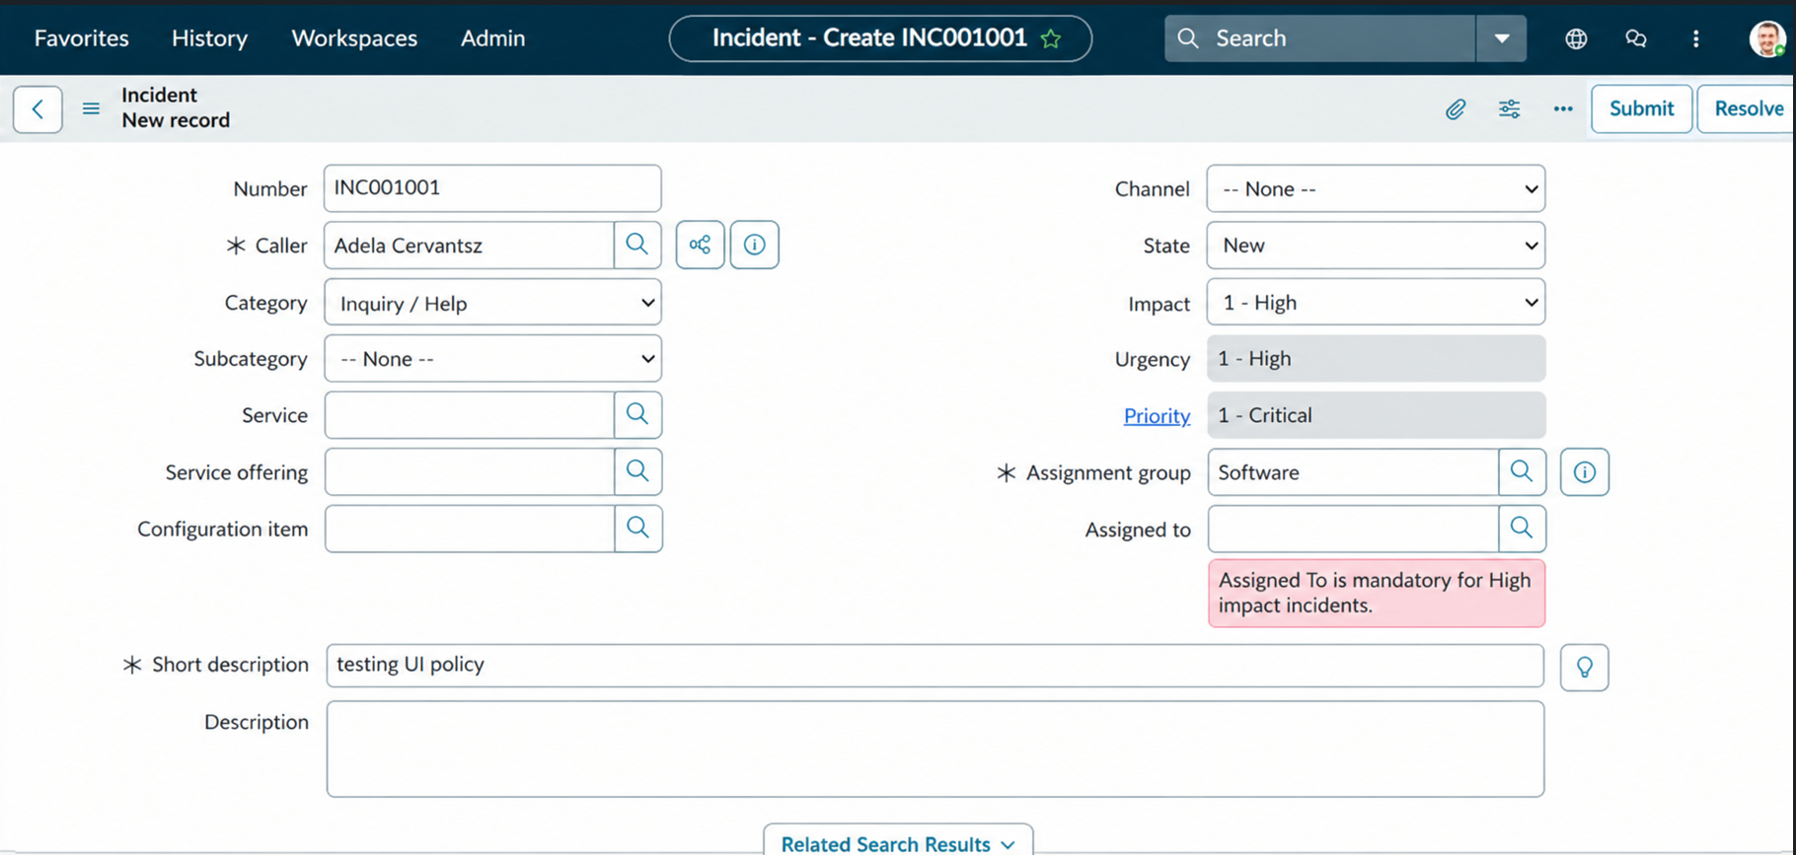
Milestone 6 Activity 1: Incident form and high-impact validation feedback.
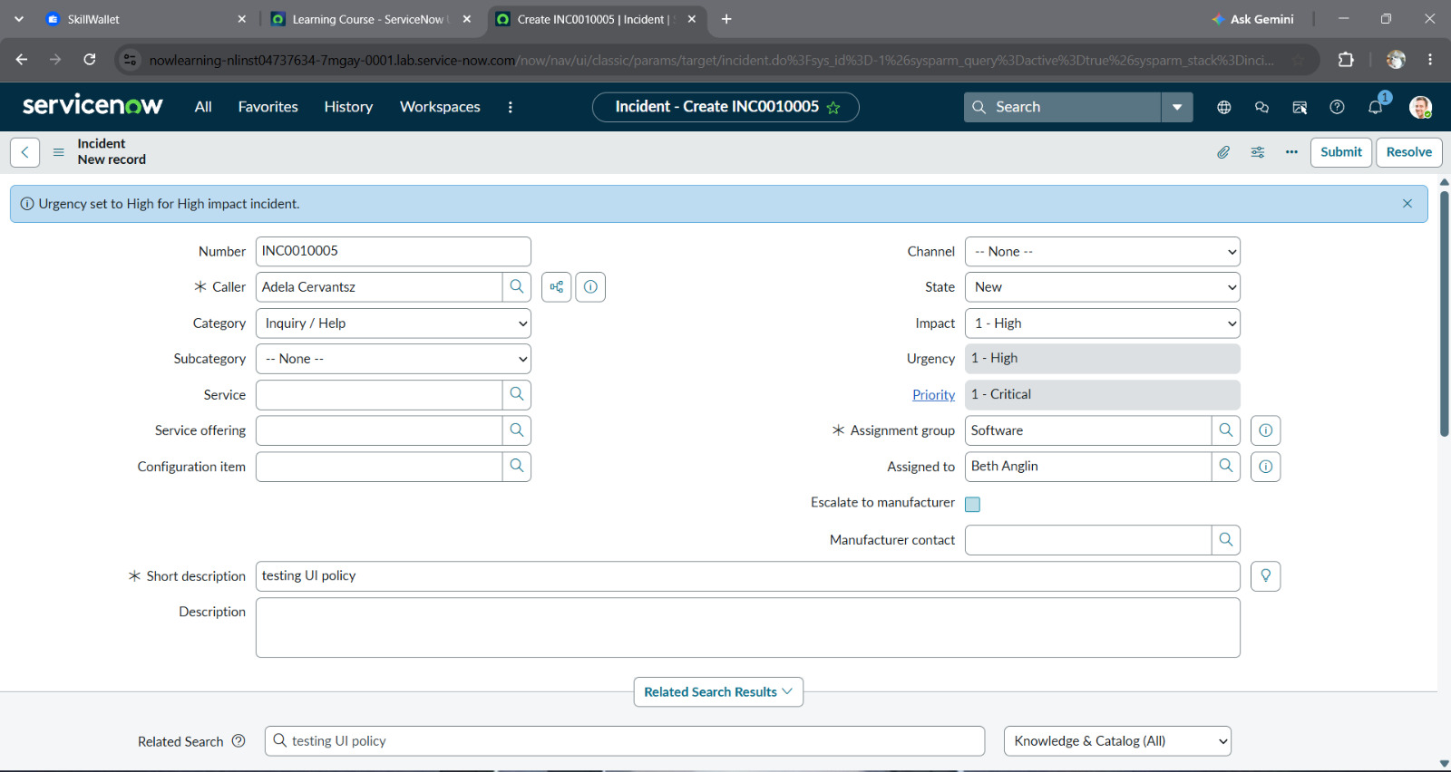
Milestone 6 Activity 2: Incident form urgency behavior.
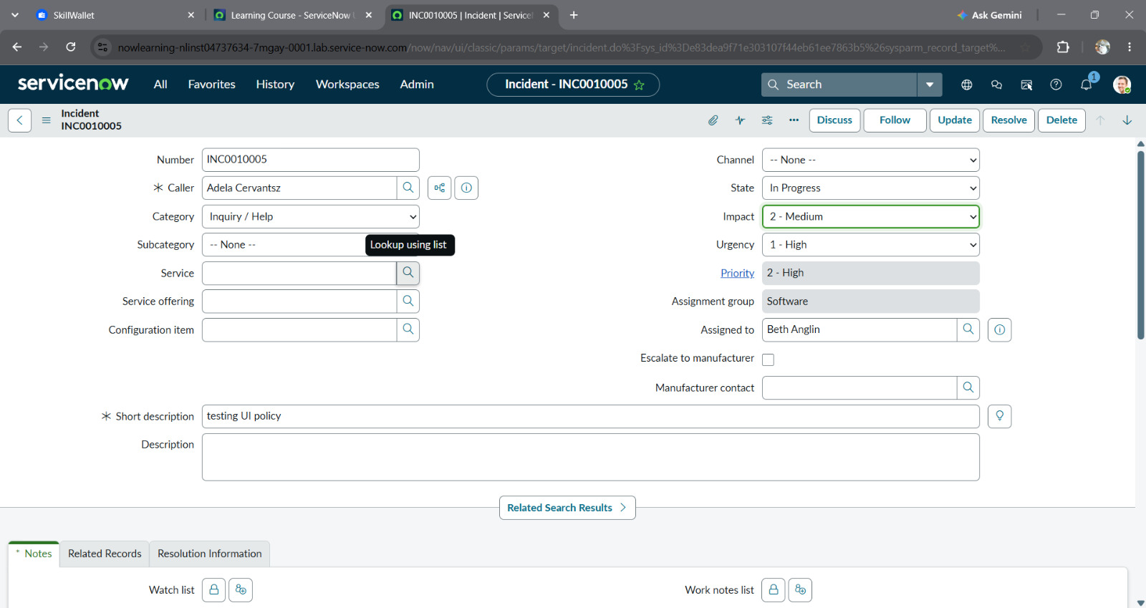
Milestone 6 Activity 3: Incident form assignment/validation view.
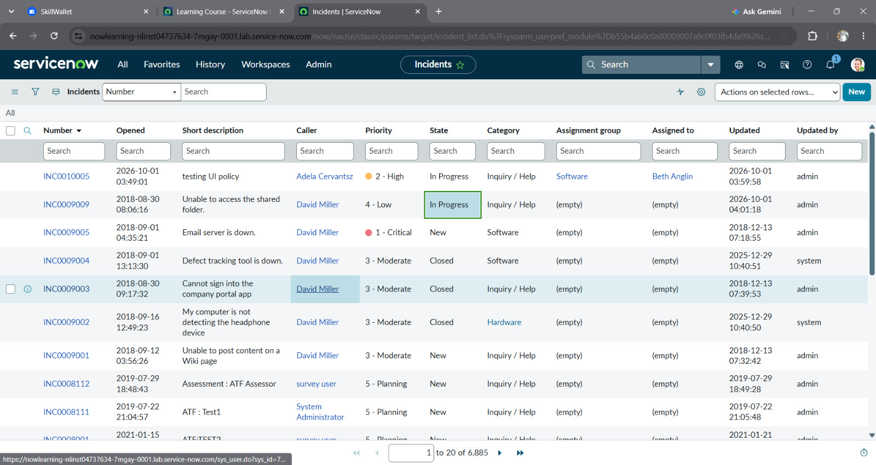
Milestone 6 Activity 4: Incident list State edit attempt.
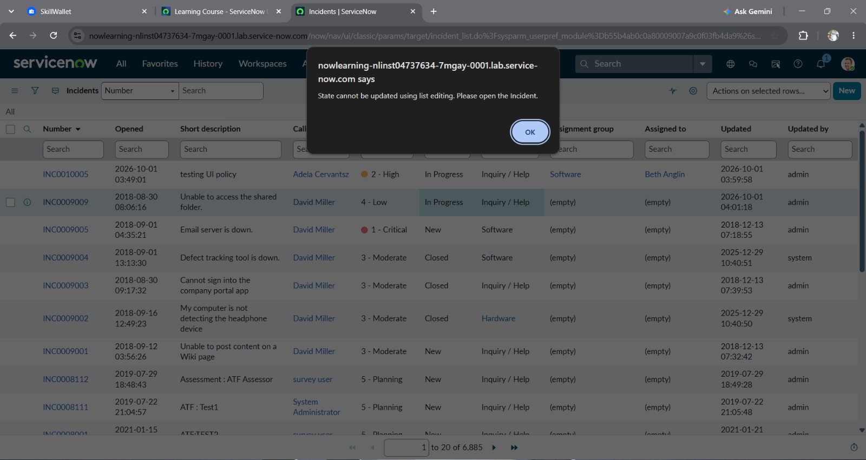
Milestone 6 Activity 4: alert shown during list edit.
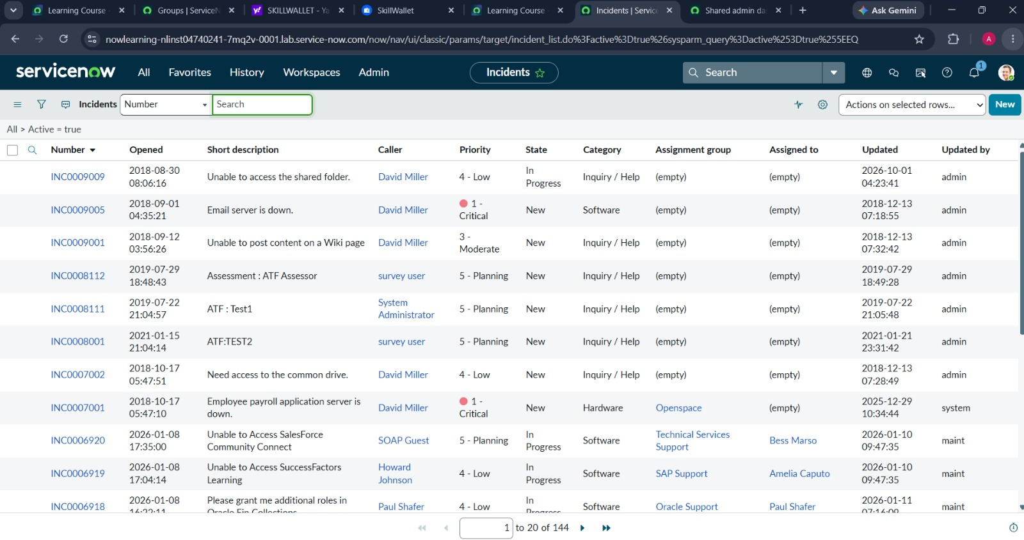
Milestone 6 Activity 5: Incident list after form-based interaction.
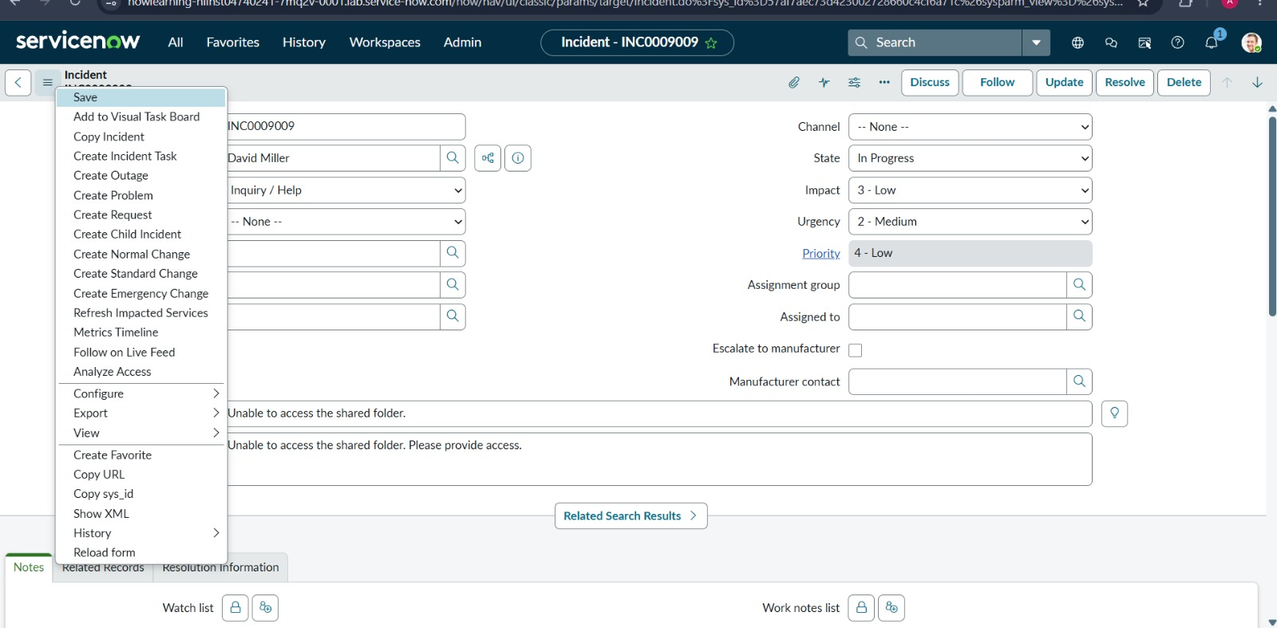
Milestone 6 Activity 5: Incident form state update view.

8. ADVANTAGES & DISADVANTAGES
Advantages | Limitations / disadvantages
Prompts and rules operate at the Incident form. | Client-side rules can be bypassed by server-side integrations or API writes.
Conditional behavior reduces some incomplete or inconsistent entries. | Conflicting mandatory-field descriptions (Assignment group vs Assigned To) require confirmation.
Native platform configuration requires no separate application stack. | No performance measurements or formal defect log were supplied.
Reverse-if-false behavior supports recovery when condition changes. | Browser, role, and platform-version behavior should be validated in the target instance.

9. CONCLUSION
The project demonstrates how an Incident UI Policy and three client script types can guide data entry, set urgency for high-impact Incidents, prevent selected incomplete submissions, and block list-based State edits. The supplied screenshots document the configuration and selected interactions. Before operational adoption, the team should confirm mandatory-field intent, retest all paths in the target instance, and add server-side validation where the rules must apply beyond the form.

10. FUTURE SCOPE
• Reconcile the Assignment group and Assigned To mandatory requirements and document the agreed rule.
• Add server-side validation for data written through APIs, imports, or background processes.
• Create a signed UAT record with tester, date, actual results, defect IDs, and release decision.
• Measure form response and script behavior under representative load; add regression checks across supported browsers and roles.
• Provide the repository/demo URL if the team publishes one; none was included in the supplied files.

11. APPENDIX

Source Code
onChange Client Script — Auto set urgency for high impact
function onChange(control, oldValue, newValue, isLoading) {
if (isLoading || newValue == '') return;
if (newValue == '1') {
g_form.setValue('urgency', '1');
g_form.addInfoMessage('Urgency set to High for High impact incident.');
}
}
onSubmit Client Script — Prevent save if Assigned To is missing
function onSubmit() {
if (g_form.getValue('impact') == '1' &&
g_form.getValue('assigned_to') == '') {
g_form.showErrorBox('assigned_to',
'Assigned To is mandatory for High impact incidents.');
return false;
}
return true;
}
onCellEdit Client Script — Prevent State list editing
function onCellEdit(sysIDs, table, oldValues, newValue, callback) {
alert('State cannot be updated using list editing. Please open the Incident.');
callback(false);
}

Dataset and Links
Dataset: Not applicable; this is a ServiceNow configuration project. GitHub repository and project demo links: not present in the supplied materials.

